Homework 5 Optimisation algorithms

1. The stations in an underground network are represented as a graph, with nodes representing the stations and weighted edges representing the connections between them. The weights represent the time taken to travel between two stations.
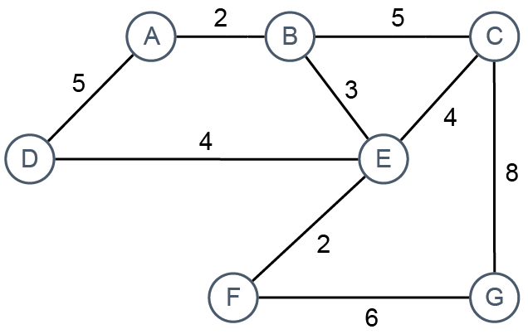

(a) Show how the graph may be represented as an adjacency list. [7]

(b) There is a well-known optimisation algorithm for finding the shortest distance between a start node and all other nodes. What is the name of the algorithm? [1]

(c) A priority queue may be used as a supporting data structure in the implementation of the algorithm. What are the main features of a priority queue? [2]

(d) The start node is A. Describe the first two steps in the algorithm. Do not include the use and operation of the priority queue in your answer. [5]

(e) Use the diagram to trace through the algorithm and calculate final distances.
What are the shortest distances from a to E, F and G? [3]

(f) State two other applications of the algorithm. [2]

[Total 20 Marks]

